**Setup Bands and Modes**

Geoff Anderson G3NPA and Aki Yoshida JA1NLX

## 1.0 GENERAL

The purpose of the Bands and Modes table is to address the difficulties associated with correctly identifying (from a DX spot) the mode a spotted station is operating and the mode into whih to place your radio. Although the program is provided with a default Bandplan that may be adequate for some users, the capability is provided for users to define their own band segment allocations (a Bandplan) for up to 200 entries.

## 2.0 CONFIGURE BANDS AND MODES

To modify, or delete a default setting or to add a new segment, on the Logger32 Main menu select the Tools |Setup Bands and Modes menu items to open the Edit Bands & Modes dialog box.

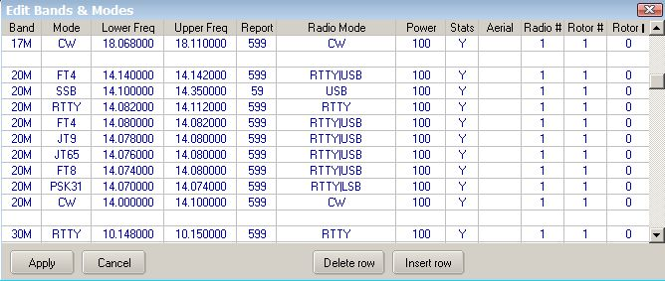

New SBM_1

See [www.adif.org.uk/adif](http://www.adif.org.uk/adif). for complete ADIF Definitions and Details

* + **Band** for this segment - Must be a valid ADIF Band;
  + **Mode** for this segment - Must be a valid ADIF Mode or Submode definition. **Note**: ~~that PSK31, PSK63 etc are not ADIF Modes but ADIF Submodes.~~ It is recommended that all entries in your BandPlan are submodes and not modes. This will allow you maximum flexibility of your personal configuration. If you operate PSK31 then put PSK31 in Mode column. If you operate FT4 then put FT4 in Mode column. See “Award Table” section in this Help
  + **Lower (sub-band) Freq** for this segment - Frequency in MHz (e.g. for 40M CW it would be 7.000};
  + **Upper (sub-band) Freq** for this segment -Frequency in MHz (e.g. for 20M SSB it would be 14.350):  
      
    **Note**: Trailing zeros will be automatically inserted for both Lower and Upper entries;
  + The order in which the segments are entered is also very important. Take a 20M example;  
    - 20M SSB 14.150 14.350 59 USB 100 Y
    - 20M RTTY 14.080 14.120 RTTY 50 Y
    - 20M PSK 14.065 14.075 USB 50 Y
    - 20M CW 14.000 14.350 CW 100 Y

The lower sub band entries **MUST** be in descending order (the higher frequency must be above the lower frequency).  In this example, the lower sub band edges are (in descending order) 14.150, 14.080, 14.065, and 14.000.

To add the SSTV sub band to 20M (in the example above), you would need to add a new line to the table. Place the cursor on the line above 20M SSB 14.150... and click <Insert Row>. You can now enter data in the additional line to the table so the entries now read:

* + - 20M SSTV 14.220 14.230 599 USB 100 Y
    - 20M SSB 14.150 14.350 59 USB 100 Y
    - 20M RTTY 14.080 14.120 RTTY 50 Y
    - 20M PSK 14.065 14.075 USB 50 Y
    - 20M CW 14.000 14.350 CW 100 Y

Click on <OK> to bring the new change into effect.

By adding this new line, you have done the following:

* + - Added SSTV as a valid mode to Logger32;
    - When the receiver is tuned to a frequency in the SSTV sub-band the Logbook Mode will default to SSTV;
    - When clicking on a DX Spot on a frequency between 14.220 and 14.230 the radio will go to the frequency and the radio mode will be set to USB.  The Logbook Mode will default to SSTV.

How does this work?  If you are tuning the radio across the 20M band (with auto poll on, and Logbook Mode controlled by the radio) starting from the bottom of 20M (14.000), the Mode in the Logbook will show CW, regardless of what mode the radio is switched to.  As you tune upward past:

* + - 14.065 the Logbook mode will change to PSK;
    - 14.075 the Logbook mode will change to CW;
    - 14.080, and the Logbook mode will change to RTTY;
    - 14.120 and the Logbook mode will change to CW;
    - 14.150, and the Logbook mode will change to SSB.

Also, take the case of a DX Spot on 14.066.  Clicking on the DX Spot will put the radio on 14.066 USB, and the Logbook to 14.066, 20M PSK.

* + **Report** - Default report for this segment (e.g. 59, 595 and 599).
  + **Radio Mode** - The mode to place the radio into for this segment.

The table below shows acceptable bandplan mode names for specific equipment. Any others are invalid. However, not ALL radio equipment will accept ALL of these for mode changing when clicking on a DX spot.

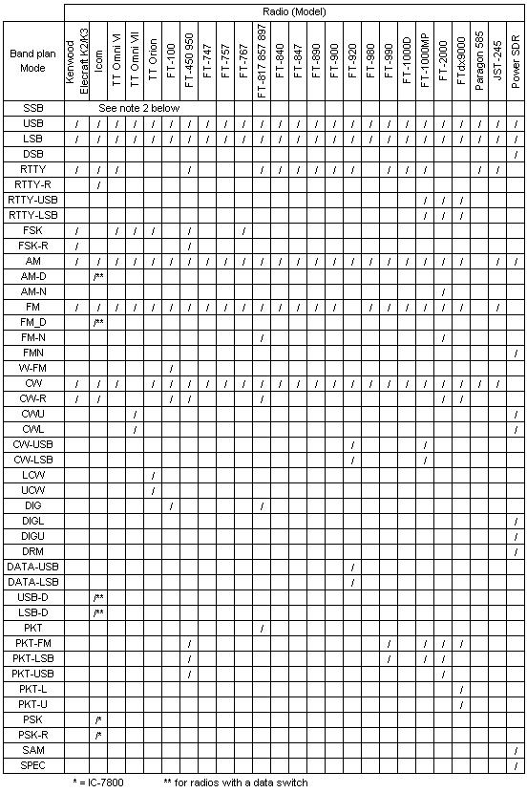

SBM_2

**Notes**:

* + 1. The use of an invalid Bandplan Mode for a particular radio will put that radio in USB or LSB depending on the frequency.
    2. All radios will accept and work correctly if one uses the simple SSB, CW, RTTY, AM, FM mode descriptions in the Bandplan. It is only some of the more obscure mode settings that may give rise to problems. However if you choose to use these descriptions, then by default SSB will select USB or LSB according to frequency. If the frequency is below 14.0 MHz then the radio will be switched to LSB. If above, the radio will be switched to USB.  CW will default to CW-USB and RTTY will default to RTTY-L.
    3. For DIG mode on the FT-100 to work properly (in combination with Logger32); menu item #34 (AFSK mode) on the FT-100 should be configured as PKT-LSB or RTTY-LSB. In addition, it is recommended that in order to have narrow band (CW filter) reception in DIG mode, set the preset audio freq in Logger32 (see Soundcard Data Window Settings | Preset audio freq) to 1700 Hz and set menu #39 on the FT-100 to the same frequency. With this setup, the CW filter is centered on 1700 Hz when enabled.
    4. Code has been added to to support SO2R radio mode. Please refer to the SO2R topic Additional facility added to the band/mode table for more information.
    5. Some ICOM radios have a DATA setting. This mode is used in conjunction with the AUX connector on the rear of the radio when receiving and transmitting Digital information. When the DATA mode is set, the radio shifts the Audio input and output to the rear Auxiliary connector. This function usually mutes the microphone so it will not interfere with the TNC/Soundcard data during transmit and a constant audio output level is provided to the AUX connector. See the ICOM General section of this help file.

**Power** - TX power to be logged for this sub band

**Stats** - An indicator to show if stats are to be calculated/displayed in the Worked/Confirmed window. If ALL band/mode slots are left blank or are marked "N," only a single small gray ~~grey~~ square will be displayed in the Worked/Confirmed window. See [Column Order in the Worked/Confirmed Window](#2.0_COLUMN_ORDER_IN_WORKED_CONFIRMED_WINDOW ) below.

**Aerial** - The Antenna Number to be used by automatic antenna switches.

**Note**: A different antenna may be selected for Radio #1 and Radio #2 for the same band segment. Example: Radio #1 uses antenna #1 and Radio #2 uses antenna #2 for the same band segment. To automate this antenna switch over the entry in the Aerial column would be "1|2" (without the quotes).

**Radio #** - The Radio to be used for this particular segment. It was originally intended that this would allow automatic switching from clicking on DX spots for those who have a second radio for the VHF/UHF bands - but if you are so inclined it could be used for similar switching between an SSB only setup and a CW only setup. The combinations are almost limitless. Also see the sections on connecting a radio to your computer in Interfacing a Radio for PC Control and Setting up to use Two Radios.

Certain radios do not automatically switch their selected antenna if the band is changed by CAT command (like they do if the band is manually changed), so the following has been implemented in the BandPlan:

Selection in the Radio # column (column 10) includes both Radio # and Radio Ant.  Similar to the format implemented in the Radio Mode column (column 6) the format is   x, xy|z or x y|z.  Where x (in the range of 1 or 2) is the default radio to use, y (in the range of 0 to 9) is the ant port on radio 1 and z (I the range of 0 to 9) is the ant port on radio 2.  If no ant is to be selected, use 0 as the antenna port number.

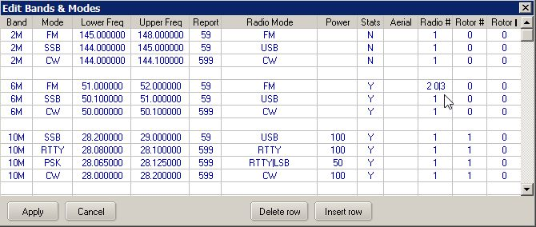

SBM_4

Some examples:

* + - "2"  This sets radio 2 as the default and no switching is done of either radio 1 or radio2 internal aerial ports.
    - "2 0|0"  Same as above.
    - "17|8"  This sets radio 1 as the default radio using internal aerial port 7.  If radio 2 is selected (say for SO2R operation) then radio 2 ant 8 is selected.
    - "1 7|8" is the same as above
    - '2 0|3"  This sets radio 2 as the default radio with internal antenna 3 selected.  Switching to radio one does not issue any aerial selection command to radio 1.

**Operational Note**:  As Logger32 does not read the Radio Antenna, reverting back to the previously selected Radio|Antenna (by menu selection) will not revert the Radio to the previously selected Antenna.

**Programming Note**:  ICOM radio code has been tested (minimal).  FT-2000 and FT-9000 code has been programmed but is untested.  Other radios that may have Radio Antenna by CAT command are unknown and have not been coded.

**Set up Note**:  The radio configuration menu AUTOMATIC RADIO CHANGE option must be checked for this feature to work.

**Rotor #** - This column is used to set the rotor number used for the particular band/frequency segment. If no Rotor is present or not used on a particular segment, then insert a 0 in this column.

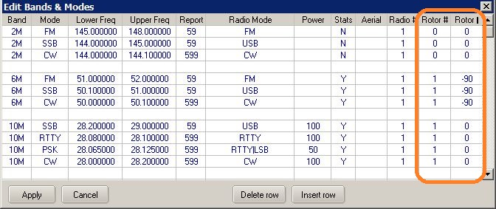

SBM_5

**Rotor \*** - This column is used to compensate for beam antennas mounted crosswise to the main beam. As an example, if the user has a 6-meter beam mounted 90 degrees clockwise from the main beam, The chart should reflect -90 in the Rotor column. This will allow Logger32 to compensate the antenna direction and point the 6-meter beam to the true heading of the partner station.

If no compensation is needed, then enter a 0 in this column.

Rotor fixed compensation for mast slippages and magnetic variations are covered in the Setup Antenna Rotator section.

## 2.0 COLUMN ORDER IN WORKED CONFIRMED WINDOW

Depending on your individual operating preferences, you may choose to have a simple Bandplan, or a very complex one.  The choice is yours.

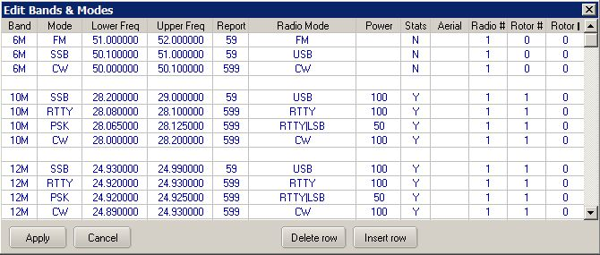

SBM_5A

A Worked/Confirmed window for the Bandplan above might look like that below.  **Note** that various options with this window are checked. See the Worked/Confirmed window topic for detail.

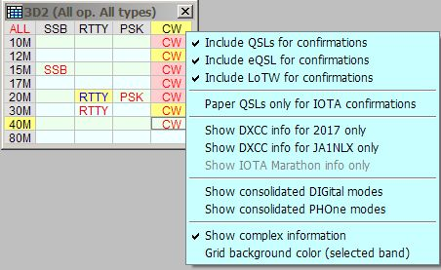

SBM_3

**Note**: The order in which the modes appear in the Worked/Confirmed window, from left to right, will be the same as the Mode order in the Bandplan from top to bottom (for those modes that are marked "Y" in the Stats column. If you compare the left to right order of the modes in the above picture with the Bandplan example shown below, you will see that they match the top to bottom order of the modes marked "Y" in the 10M section.

In order to produce all the stats for each band and mode, it is only really necessary to mark one "Y" in each band for one mode. If you carefully select which of these you mark with a "Y", then it is possible to change the order of appearance of these modes in the Worked/Confirmed window. For example, if the Stats column in the top line of the table below were changed to "N", then the worked confirmed window would display the modes in the order PSK31, RTTY, CW, SSB (the SSB coming from the top line of the 12M entry).